3.92:
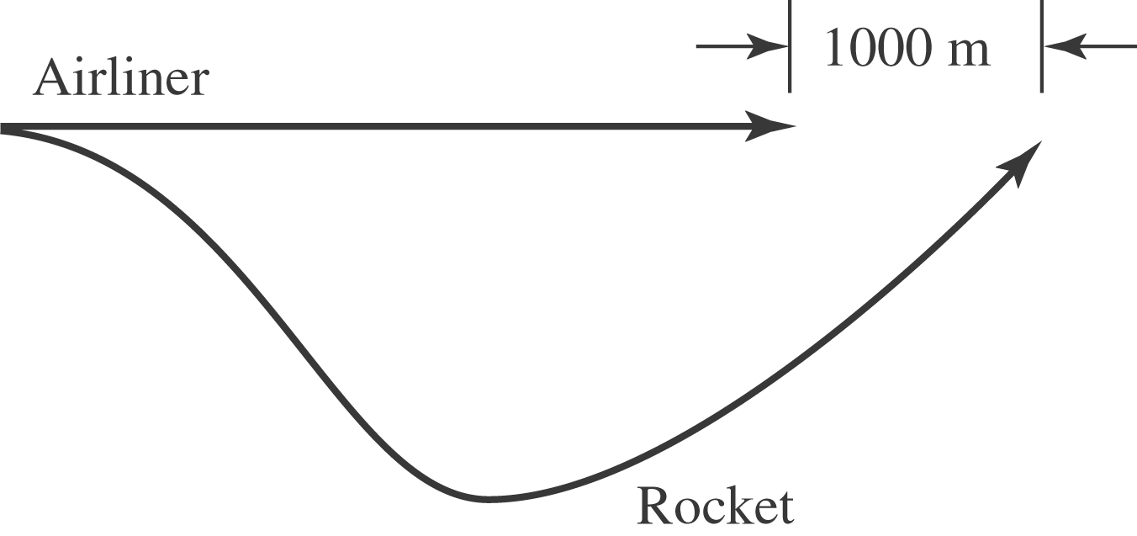

The x-position of the plane is 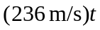 and the x-position of the rocket is The graphs of these two have the form,
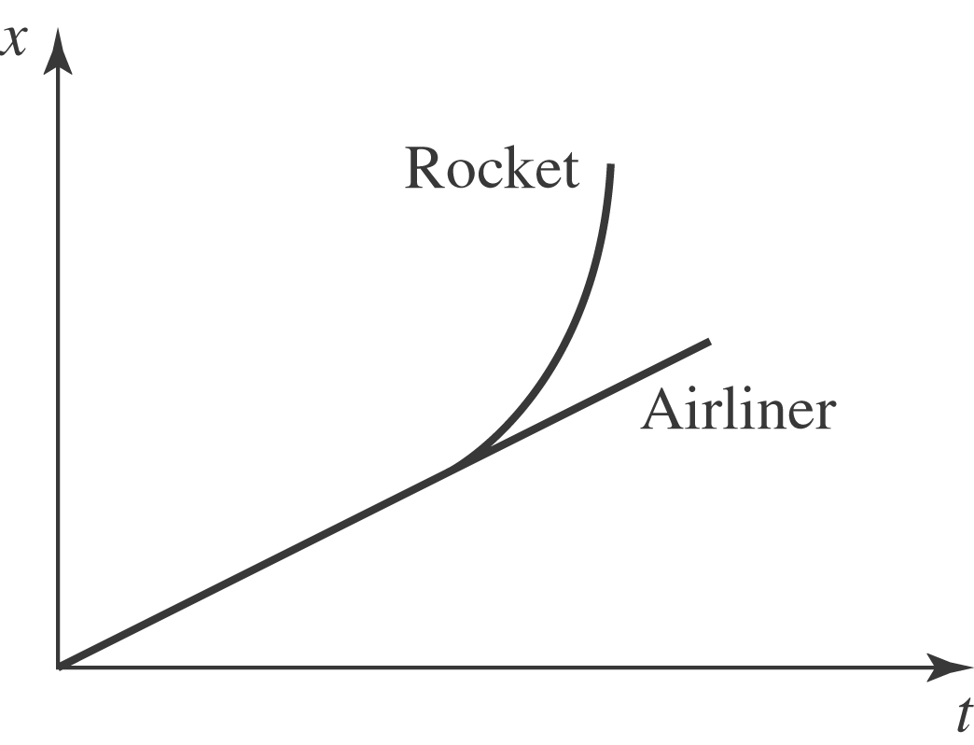
If we take 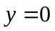 to be the altitude of the airliner, then for the rocket. This graph looks like
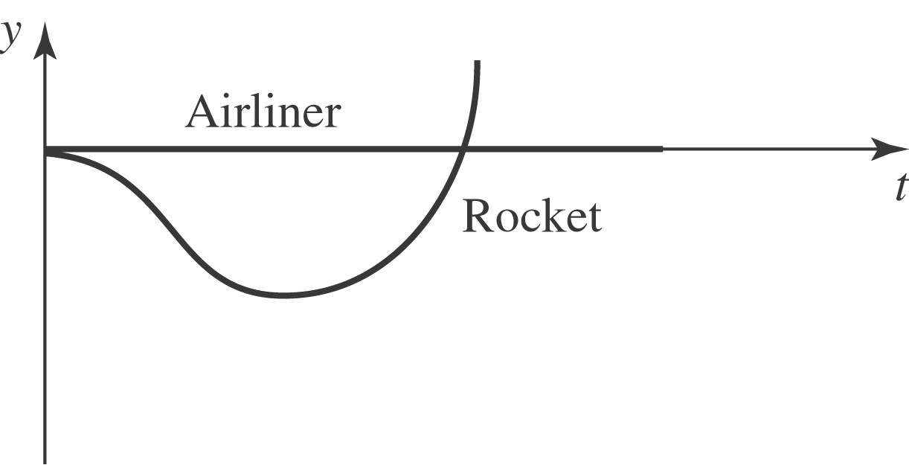
By setting for the rocket, we can solve for t in terms of Using the quadratic formula for the variable 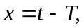 we find 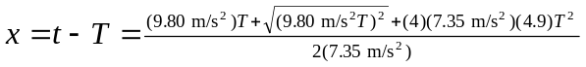 or 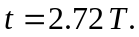 Now, using the condition that 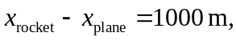 we find or 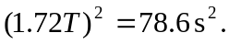 Therefore 